STATISTICS WORKSHEET-3

1.b

2.c

3.a.

4.a

5.c

6.

7.b

8.d

9 .a

10.

**Bayes’ theorem** describes the probability of occurrence of an event related to any condition. It is also considered for the case of [conditional probability](https://byjus.com/maths/conditional-probability-and-conditional-probability-examples/). Bayes theorem is also known as the formula for the probability of “causes”. For example: if we have to calculate the probability of taking a blue ball from the second bag out of three different bags of balls, where each bag contains three different colour balls viz. red, blue, black. In this case, the probability of occurrence of an event is calculated depending on other conditions is known as conditional probability. In this article, let us discuss the statement and proof for Bayes theorem, its derivation, formula, and many solved examples.

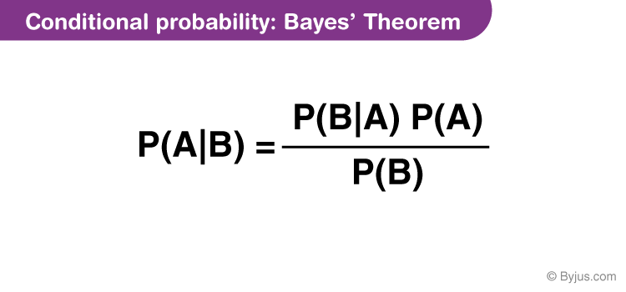

11. Z score is an important concept in statistics. Z score is also called standard score. This score helps to understand if a data value is greater or smaller than mean and how far away it is from the mean. More specifically, Z score tells how many standard deviations away a data point is from the mean.

***Z score = (x -mean) / std. deviation***

A normal distribution is shown below and it is estimated that  
68% of the data points lie between +/- 1 standard deviation.  
95% of the data points lie between +/- 2 standard deviation  
99.7% of the data points lie between +/- 3 standard deviation

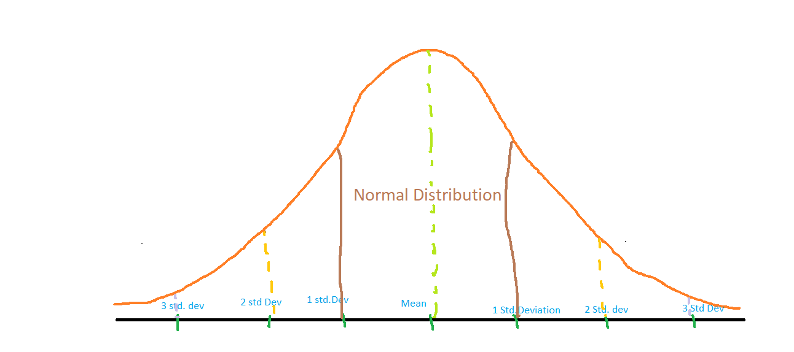  
**Z score and Outliers:**  
If the z score of a data point is more than 3, it indicates that the data point is quite different from the other data points. Such a data point can be an outlier.  
For example, in a survey, it was asked how many children a person had.  
Suppose the data obtained from people is

12. A t-test is an inferential [statistic](https://www.investopedia.com/terms/s/statistics.asp) used to determine if there is a significant difference between the means of two groups and how they are related. T-tests are used when the data sets follow a normal distribution and have unknown variances, like the data set recorded from flipping a coin 100 times.

The t-test is a test used for hypothesis testing in statistics and uses the t-statistic, the [t-distribution](https://www.investopedia.com/terms/t/tdistribution.asp) values, and the degrees of freedom to determine statistical significance.

* A t-test is an inferential statistic used to determine if there is a statistically significant difference between the means of two variables.
* The t-test is a test used for hypothesis testing in statistics.
* Calculating a t-test requires three fundamental data values including the difference between the mean values from each data set, the standard deviation of each group, and the number of data values.
* T-tests can be dependent or independent.

13. Percentiles are used in statistics to give you a number that describes the value that a given percent of the values are lower than.

Ex-import numpy  
  
 ages = [5,31,43,48,50,41,7,11,15,39,80,82,32,2,8,6,25,36,27,61,31]  
  
x = numpy.percentile(ages, 75)  
  
print(x)

Or

The nth percentile of a dataset is the value that cuts off the first *n* percent of the data values when all of the values are sorted from least to greatest.

For example, the 90th percentile of a dataset is the value that cuts of the bottom 90% of the data values from the top 10% of data values.

We can quickly calculate percentiles in Python by using the [numpy.percentile()](https://numpy.org/doc/stable/reference/generated/numpy.percentile.html" \t "_blank) function, which uses the following syntax:

numpy.percentile(a, q)

14. Analysis of variance (ANOVA) is an analysis tool used in statistics that splits an observed aggregate variability found inside a data set into two parts: systematic factors and random factors. The systematic factors have a statistical influence on the given data set, while the random factors do not. Analysts use the ANOVA test to determine the influence that independent variables have on the dependent variable in a regression study.

The t- and [z-test methods](https://www.investopedia.com/terms/z/z-test.asp) developed in the 20th century were used for statistical analysis until 1918, when Ronald Fisher created the analysis of variance method.12 ANOVA is also called the Fisher analysis of variance, and it is the extension of the t- and z-tests. The term became well-known in 1925, after appearing in Fisher's book, "Statistical Methods for Research Workers."3 It was employed in experimental psychology and later expanded to subjects that were more complex

**The Formula for ANOVA is:**

F=MSE\MST

​**where:**F=ANOVA coefficient

MST=Mean sum of squares due to treatment

MSE=Mean sum of squares due to error

15. ANOVA is helpful for **testing three or more variables**. It is similar to multiple two-sample t-tests. However, it results in fewer type I errors and is appropriate for a range of issues. ANOVA groups differences by comparing the means of each group and includes spreading out the variance into diverse sources.